Cape Economic Performance and Prospect Bulletin – October 2026
Highlights
- CAPE expects headline inflation to reach 15.47 per cent in September 2026, within a 15.30–15.64 per cent forecast range. Relative to the 15.39 per cent outturn in August, inflation is projected to accelerate. Consumer prices are expected to rise by 0.79 per cent during the month.
- Nigeria’s real GDP growth strengthened to 4.43 per cent in Q2 2026. CAPE nowcasts Q3 2026 growth at 4.43 per cent, within its reporting range of 4.17–4.55 per cent. The point forecast is virtually unchanged from the Q2 outturn, with upside potential suggested by the upper bound of the range.

Global Economic Update
Global growth remains moderate amid heightened uncertainty. The IMF’s July 2026 World Economic Outlook Update projects expansion of 3.0 per cent in 2026 and 3.4 per cent in 2027. Resilient services and technology investment support activity, while energy shocks, trade tensions and high borrowing costs weigh on the outlook.
Growth prospects remain uneven. Economies with stronger domestic demand and greater access to finance are better placed to absorb external shocks. Highly indebted and import-dependent economies have less room to protect households and businesses from higher costs.
Trade-policy uncertainty continues to complicate business planning. Changes in tariffs and supply routes raise procurement costs and working-capital needs, particularly for smaller firms. Prolonged fragmentation would also weaken investment and productivity by reducing access to markets and efficient production networks.
Major advanced-economy central banks maintained a cautious stance in July. The Federal Reserve held its target range at 3.50–3.75 per cent, the European Central Bank retained its 2.25 per cent deposit rate, and the Bank of England left Bank Rate at 3.75 per cent. Persistent inflation pressures continue to limit the scope for monetary easing.
Emerging-market performance remains mixed. Domestic demand and investment support activity in parts of Asia, while debt-service burdens and currency pressures constrain several frontier markets. For African economies, export opportunities must be weighed against exposure to imported fuel, food and financing costs.
The IMF projects global headline inflation at 4.7 per cent in 2026, up from 4.1 per cent in 2025, before easing to 3.9 per cent in 2027. Renewed energy pressures have interrupted disinflation, with fuel, freight and fertiliser costs transmitting into broader consumer prices.
Figure 1: Year-on-Year Inflation in Selected Economies (May 2025 – June 2025) in percent

Source: Various National Statistics Offices
The pace of future interest-rate reductions will depend on whether inflation pressures recede sustainably. Premature easing could prolong inflation, while excessive restraint would weaken investment and employment. Differences in labour markets and exposure to imported energy are likely to produce divergent policy paths.
In Nigeria, the Monetary Policy Committee retained the Monetary Policy Rate at 26.5 per cent and the cash reserve ratio for deposit money banks at 45.0 per cent in July 2026. The restrictive stance supports price stability but keeps borrowing costs elevated. Improvements in food supply, transport and energy remain essential to reducing inflation without placing undue pressure on output.
Financial markets remain sensitive to inflation, interest-rate expectations and geopolitical developments. For frontier economies, sustained capital inflows will depend on credible policy and confidence in currency stability. A renewed shift towards safer assets could tighten external financing conditions even where domestic activity remains resilient.
Conflict and uncertainty around major shipping routes continue to threaten supply chains. Higher freight and insurance costs can feed into consumer prices and strain firms’ cash flow. Import-dependent economies are particularly exposed, especially where domestic security and infrastructure constraints already raise distribution costs.
Oil markets reflect competing pressures. The International Energy Agency reported global supply of 101.5 million barrels per day in July 2026 while lowering its forecast for annual demand growth. North Sea Dated crude ended July near US$96.80 per barrel and traded around US$92 at the time of the August report. Softer demand could weigh on prices, but further supply disruptions remain an upside risk.
For Nigeria, higher crude prices can strengthen export and fiscal receipts only if production is sustained. The IEA estimated July output at about 1.44 million barrels per day, below the 1.5 million-barrel-per-day target. Higher oil prices also raise domestic fuel and transport costs, limiting the benefit to households and non-oil businesses.
The external environment therefore presents both opportunities and risks for Nigeria. Stronger export receipts could support fiscal and foreign-exchange conditions, while renewed energy shocks or tighter global financing would increase domestic pressures. Reliable oil production and stronger non-oil competitiveness remain central to resilience.

Global Economic Outlook
Global expansion is expected to continue through the remainder of 2026, though the recovery remains vulnerable to energy and trade disruptions. Stronger investment would improve the durability of growth; a renewed squeeze on household purchasing power would weaken demand.
Monetary easing is likely to remain gradual and uneven. In Nigeria, sustained disinflation and currency stability would improve the scope for a less restrictive policy stance. Until then, high financing costs are likely to constrain investment and consumption.
Commodity-price volatility remains a key risk. Favourable harvests could ease food prices, but adverse weather, insecurity and distribution bottlenecks may limit the relief reaching consumers. Oil-price gains should be treated cautiously in fiscal planning because both prices and production can reverse quickly.
Policy priorities remain clear: protect productive investment, improve energy and transport reliability, and rebuild fiscal buffers. Predictable implementation would strengthen business confidence and help economies absorb external shocks.

Nigeria’s Output Growth
Nigeria’s real GDP grew by 4.43 per cent year-on-year in Q2 2026, up from 3.89 per cent in Q1. Expansion across services, agriculture and industry points to a broadening recovery. The stronger outturn is encouraging, although sustained gains in employment and household purchasing power remain the more demanding test of economic progress.
The Central Bank of Nigeria Composite Purchasing Managers’ Index (PMI) rose to 53.0 points in September 2026 from 52.7 points in August. This marks 4 consecutive months above the 50.0 threshold and signals continued private-sector expansion. The reading indicates a broadening expansion in domestic activity, although elevated financing, energy, transport and input costs continue to compress operating margins.
Figure 2: Trend of Nigeria’s CBN Composite PMI (Aug 2025–Sep 2026)
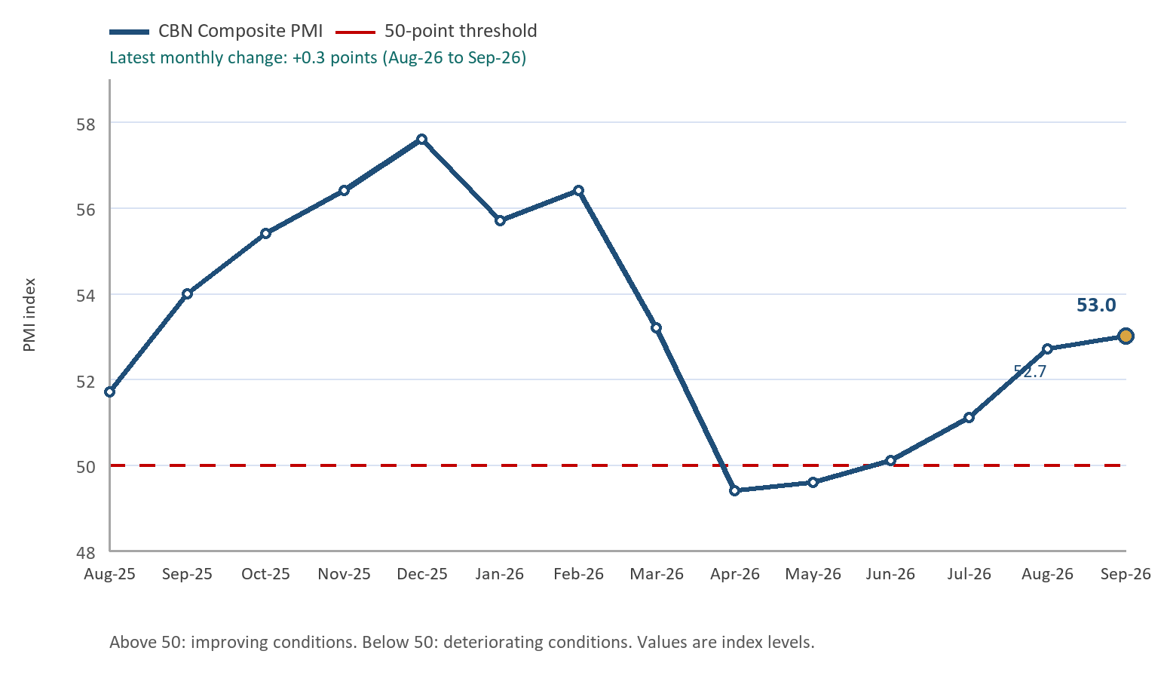

Source: Central Bank of Nigeria (CBN)

The CBN Composite PMI strengthened from 52.7 in August to 53.0 in September, remaining above the 50-point expansion threshold. The improvement supports a firmer near-term activity profile, but the durability of the expansion will depend on reliable power and transport services, access to working capital and continued foreign-exchange stability.
Services remained the largest component of output, growing by 4.60 per cent and accounting for 56.62 per cent of GDP. Agriculture and industry expanded by 4.39 per cent and 3.96 per cent respectively. Growth of 7.31 per cent in the oil sector complemented a 4.31 per cent expansion in non-oil activity.
The recovery nevertheless remains uneven. Insecurity, infrastructure gaps and high business costs limit investment and job creation. Addressing these constraints would help translate aggregate growth into broader improvements in living standards.

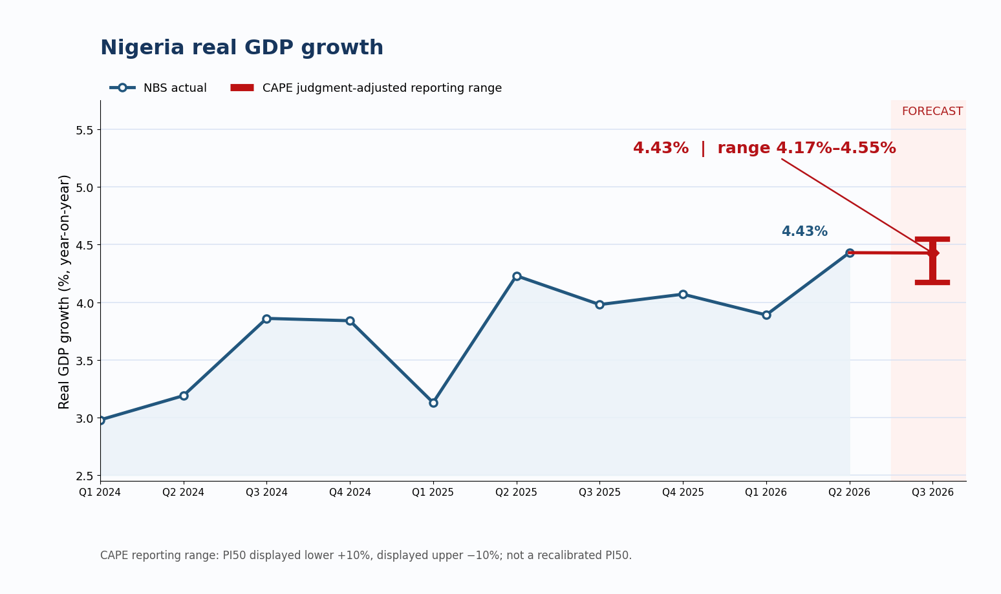
Figure 3: Nigeria Real GDP Growth and CAPE Q3 2026 Reporting Range (Q1 2024–Q3 2026), per cent

Source: National Bureau of Statistics (NBS) and CAPE Economic Research and Consulting

Output Growth Outlook
CAPE nowcasts real GDP growth at 4.43 per cent year-on-year in Q3 2026, within its reporting range of 4.17–4.55 per cent. This is broadly unchanged from the 4.43 per cent expansion recorded in Q2 2026. Firmer private-sector activity and improved order books provide support, while high financing costs, energy and logistics expenses, insecurity and subdued household purchasing power remain constraints. The reporting range reflects a 10 per cent upward adjustment to the displayed lower bound and a 10 per cent downward adjustment to the displayed upper bound of the provisional PI50. The unchanged point estimate is 4.43 per cent; the original statistical PI50 remains 3.79–5.06 per cent and is not replaced by this judgment-adjusted range.
Figure 4: Nigeria Economic Policy Uncertainty Index
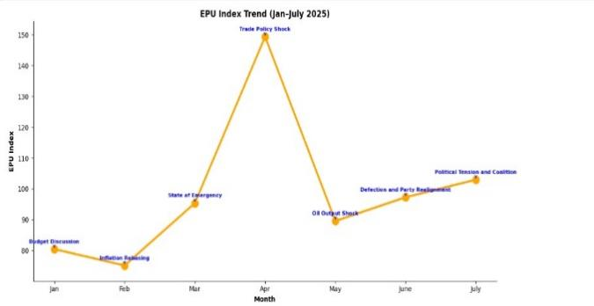
August 2026 update
EPU index: 87.10881
Policy uncertainty eased
Source: CAPE ERC. Latest index: 87.10881 (August 2026).
CAPE’s Economic Policy Uncertainty index eased to 87.11 in August 2026. Lower uncertainty may support business planning and investment, although lasting confidence will depend on consistent policy implementation and a stable operating environment.

Price Update
Headline inflation eased to 15.39 per cent year-on-year in August 2026, from 15.45 per cent in July; this represents a 0.06 percentage-point decline. The consumer price index rose by 0.69 per cent during the month. The movement in the annual rate therefore reflects the interaction of current price pressures and base effects, rather than a fall in the price level.

Figure 5: Nigeria Headline Inflation and CAPE September 2026 Forecast (Jul 2025–Sep 2026)
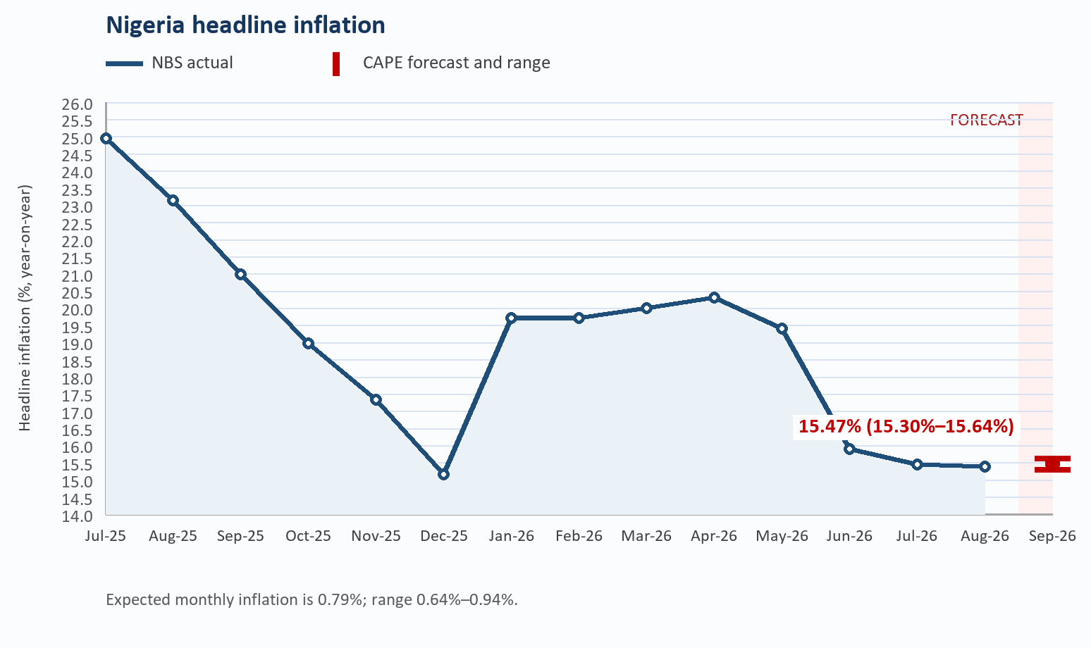
Source: National Bureau of Statistics (NBS) and CAPE Economic Research and Consulting

Food inflation rose to 20.31 per cent year-on-year in July, with a monthly increase of 4.13 per cent, as lean-season pressures affected staple supplies. Core inflation eased to 14.97 per cent year-on-year and 0.64 per cent month-on-month. Food availability and distribution costs remain important risks to the near-term inflation outlook.

Price Outlook

CAPE forecasts headline inflation at 15.47 per cent in September 2026, within a 15.30–15.64 per cent range. The annual rate is projected to accelerate relative to August. Consumer prices are expected to rise by 0.79 per cent during the month. Across the forecast range, the monthly increase would lie between 0.64 and 0.94 per cent. The balance of risks remains sensitive to food supply conditions, transport and energy costs, exchange-rate pass-through, insecurity and the stance of monetary policy.

Fiscal Operations Update
Higher federation receipts increased the resources available to federal, state and local governments in August 2026. The improvement offers short-term fiscal relief, but its lasting value will depend on revenue stability and the quality of public spending.
The Federation Account Allocation Committee distributed ₦3.007 trillion from July revenue, compared with ₦2.551 trillion from June, an increase of about 17.9 per cent. Gross statutory revenue reached ₦4.359 trillion, while value-added tax receipts stood at ₦793.968 billion. Stronger statutory receipts accounted for most of the increase.
Figure 6: Total Distributable Revenue (Jan.–Jul. 2026)
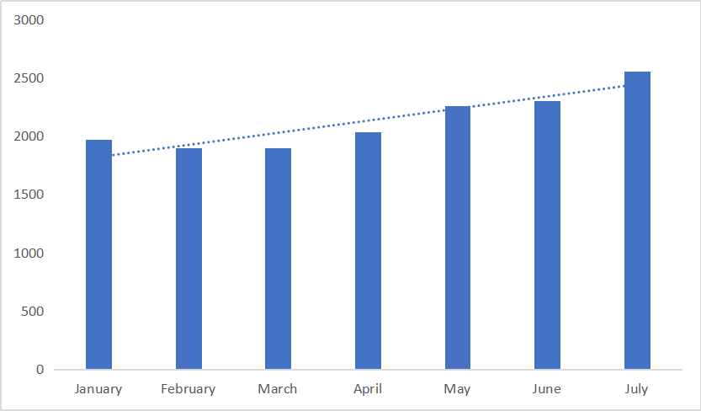
Source: FAAC
The Federal Government received ₦1.146 trillion, state governments ₦943.352 billion and local government councils ₦673.649 billion. Oil-producing states received a further ₦243.478 billion in derivation revenue.
Larger transfers should ease immediate financing pressures, particularly at state and local levels. Sustained fiscal improvement will require stronger revenue collection, reliable oil production and disciplined spending. Saving part of higher receipts would help protect essential services when revenues weaken.

Conclusion
Global growth remains positive, but energy shocks, trade uncertainty and high financing costs continue to pose risks. For Nigeria, the benefits of stronger export receipts must be balanced against exposure to imported inflation and volatile capital flows.
Nigeria enters October with stronger activity but persistent cost pressures. Real GDP growth accelerated to 4.43 per cent in Q2 2026. CAPE nowcasts 4.43 per cent growth in Q3 2026, within a reporting range of 4.17–4.55 per cent. Stronger federation receipts provide some fiscal relief, while headline inflation is projected to accelerate to 15.47 per cent in September, within a 15.30–15.64 per cent range. Sustaining the recovery will require improvements in security, food distribution, energy supply and the investment climate.

Country in Focus – Republic of Somalia
Figure 7: Economic Parameters for Republic of Somalia
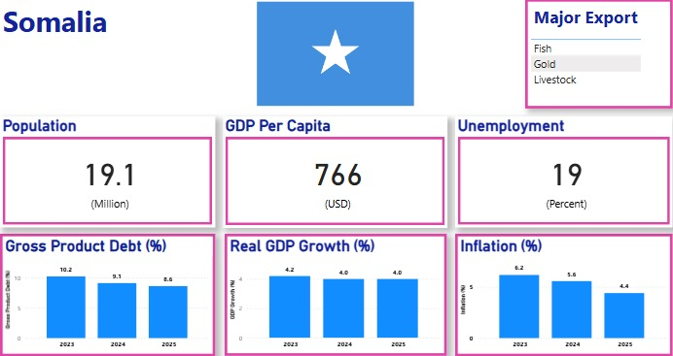
Source: CAPE Economic Research and Consulting, 2025

